EXCEPTION HANDLING:

1)SINGLE CATCH:

#include<iostream>

using namespace std;

int main()

{

int a,b;

try{

cout<<"entre two num";

cin>>a>>b;

cout<<"before;\n";

if(b==0){

throw"division by zero";

cout<<"after throws\n";

}

else

cout<<a/b;

}

catch(const char \*e)

{

cout<<e;

}

cout<<"after catch:\n";

return 0;

}

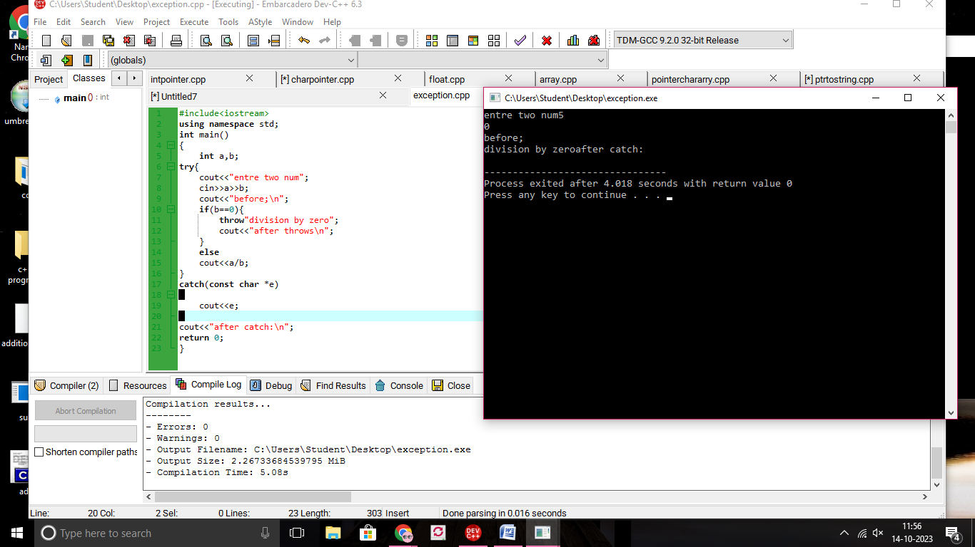

2)MULTIPLE CATCH FOR VOTE:

#include<iostream>

using namespace std;

int main()

{

int age,person;

try{

cout<<"entre age and person";

cin>>age>>person;

cout<<"before;\n";

if(age<=18){

throw"not eligible for vote";

}

else

cout<<"eligible";

}

catch(const char \*e)

{

cout<<e;

}

catch(const int \*x)

{

cout<<x;

}

cout<<"after catch:\n";

return 0;

}

